From the LaFayette Advisory Conservation Commission
LaFayette Residents Make Great Volunteers!

In the second quarter newsletter, the LaFayette Advisory Conservation Commission (LACC) asked for candidates to serve as volunteers. In the last newsletter, eight members were announced as appointed to serve, including two high school students. Since then, three more volunteers raised their hands and are now also LACC members. We welcome: Markus Schaub, Rachel Zevin, and Doug Anderson.
It’s a good thing we have more members because our projects increased at the same rate! Here are what we are working on at the request of our Town:
- Comprehensive Plan Update – participation on the Tiger Team
- Community/Senior Center – recommendations to connect visitors to Stafford Park
- Parks – recommendations to increase visitors connection with nature at our Parks
- Tree Planting – coordination of tree plantings to replace trees removed from Bailey Park
- Community Noise – recommendations to Town’s noise ordinance
- Solar Farms – recommendations for siting considerations
- Agritourism – consultation on a possible initiative
- Electric Car Charging Stations – research of costs and grants
- Stormwater Control – recommendations to better control stormwater runoff
- Wild Parsnip – recommendations to manage this hazardous plant in our Parks*
*Visitors to Stafford and Bailey Parks will now find signs warning visitors not to touch wild parsnip
Community/Senior Center: SUNY ESF’s landscape architecture program has agreed to design, at no cost to the Town, a ravine landscape and nature walk that will include new plantings at Stafford Park. You will hear more about this next Spring/Summer as we share the designs. Yet another Stafford Park improvement project!
We welcome your ideas and inputs. So please reach out to the LACC chairperson, Mark Distler (markdistler@gmail.com) or any member with your thoughts. We hope you enjoy our article about plastic pollution.

People & Plastic Pollution – Part I
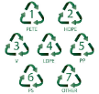
This is the first of two articles about plastics in our environment, how we are exposed to plastic pollution, and what can we do about it. This first article clarifies how best to handle common consumer waste plastic. There are two things to keep in mind:
- What we can put in our blue bins is no longer about the recycling symbols

- What we can take to stores for recycling is more than plastic shopping bags
Here are the three ways to handle our waste plastic
- Place In Blue Bin
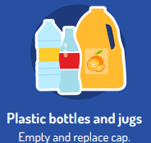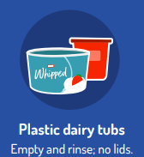
Learn more
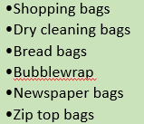
- Collect & Take to Grocery or Retail Stores
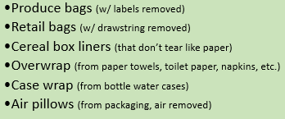
Learn more
- Put in Trash
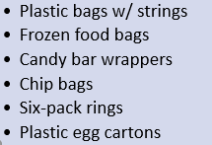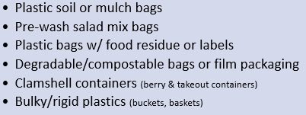
Learn more
In our next article, we explain why we want to handle our waste plastic these ways. It will discuss how we are exposed to plastic, how it may affect our health, and what we can do to reduce our exposures.

